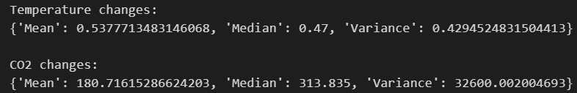
The mean temperature change is approximately 0.54°C, with a median of 0.47°C and a variance of 0.43, indicating slight variability in temperature anomalies. For CO₂ concentrations, the mean is 180.72 ppm, the median is significantly higher at 313.84 ppm, and the variance is 32,600, which reflects substantial variability in CO₂ levels over the dataset’s timeframe.
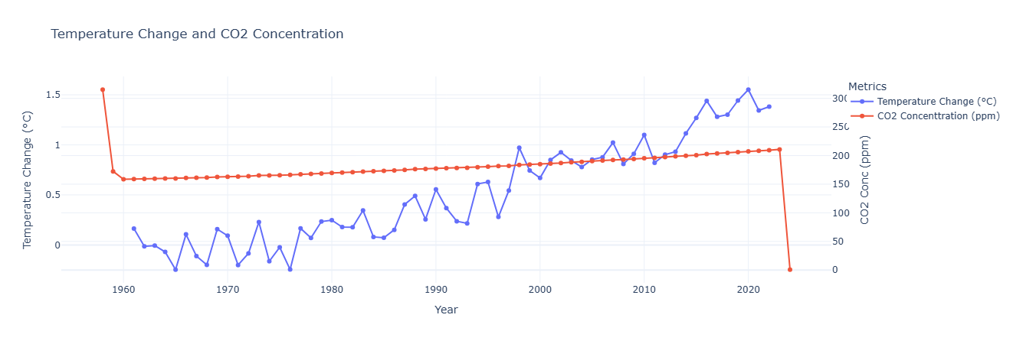The time-series graph shows a consistent increase in CO₂ concentrations (ppm) over the years, indicating the accumulation of greenhouse gases in the atmosphere. A slight upward trend in global temperature change suggests that rising CO₂ levels are associated with global warming. This supports the hypothesis of CO₂’s significant contribution to temperature increase.

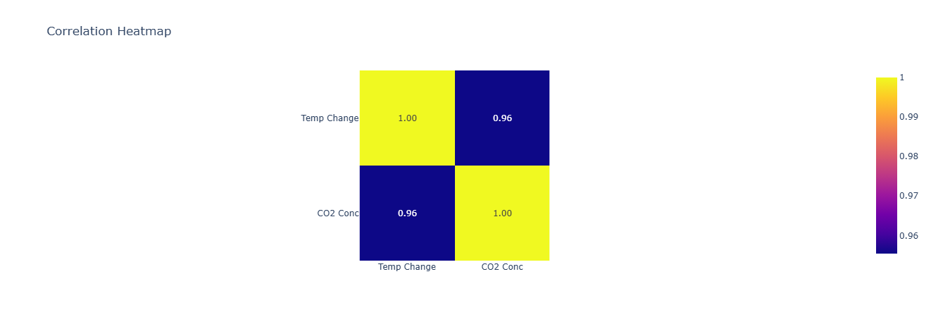
The heatmap reveals a strong positive correlation (0.96) between CO₂ concentrations and temperature changes. This reinforces the observation that higher CO₂ levels are closely linked with increasing global temperatures
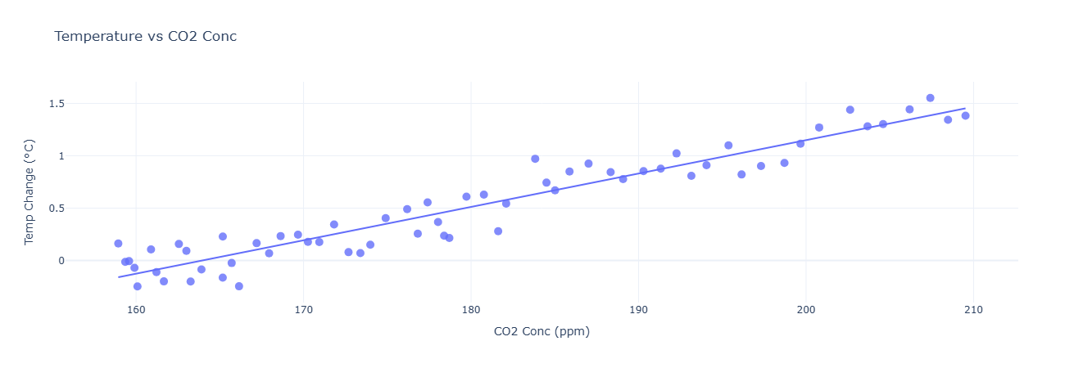
The scatter plot shows a clear linear trend, where higher CO₂ concentrations correspond to greater temperature changes. This visual evidence supports the direct relationship between CO₂ emissions and global warming.
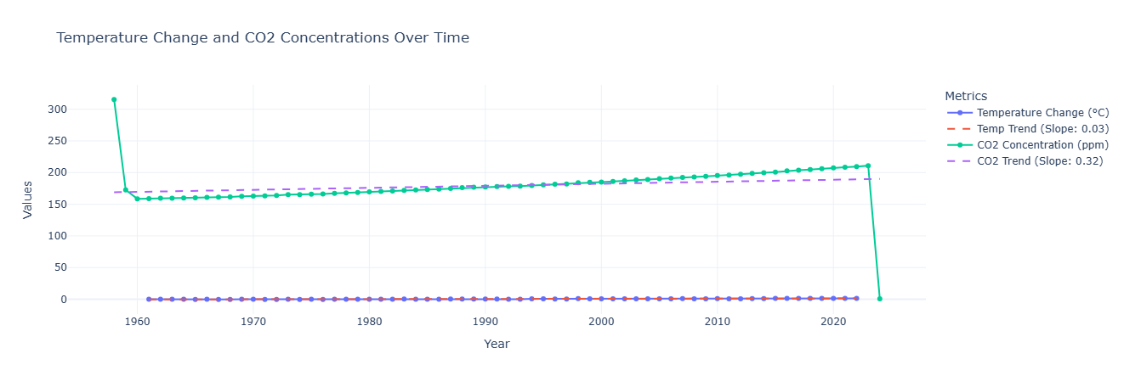This graph shows the linear trends in both temperature change and CO₂ concentrations over time, represented by their respective slopes. The CO₂ trend has a much steeper slope (0.32) compared to temperature (0.03), which indicates a faster rate of increase in CO₂ emissions relative to temperature change. This suggests that while CO₂ levels are rising rapidly, the temperature impact, though slower, is accumulating steadily and may have long-term consequences.
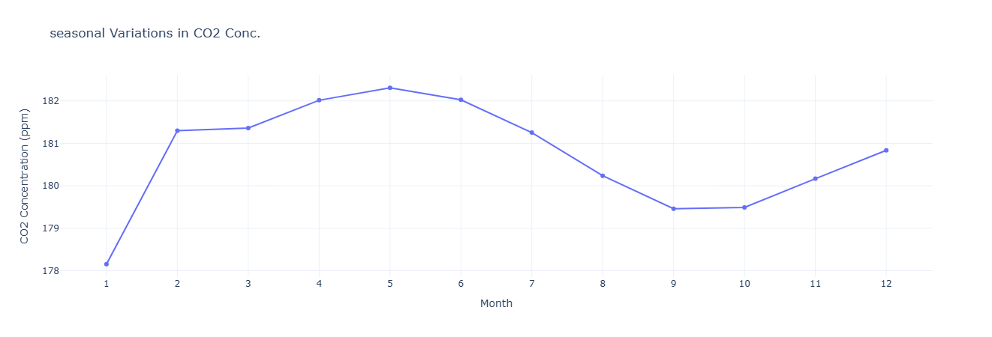
This graph highlights the seasonal fluctuations in CO₂ concentrations, which peak during late spring and early summer (around May) and reach the lowest levels in fall (around September). These variations are likely due to natural processes such as plant photosynthesis, which absorbs CO₂ during the growing season, and respiration, which releases CO₂ in the off-season indicating the effect of natural carbon sinks in moderating CO₂ levels.

There is a very strong correlation between CO₂ concentrations and temperature changes. However, Granger Causality tests do not provide strong evidence that changes in CO₂ concentrations directly cause changes in temperature within the lags tested.

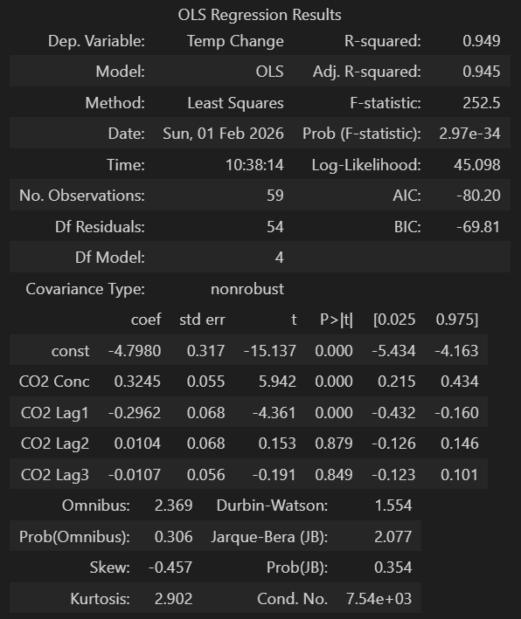
The OLS regression results indicate a strong relationship between CO₂ concentration and temperature change, with an R-squared value of 0.949, meaning 94.9% of the variance in temperature change is explained by the model. The coefficient for CO₂ concentration (0.3245) is statistically significant (p < 0.05), which suggests a positive association between CO₂ levels and temperature change.

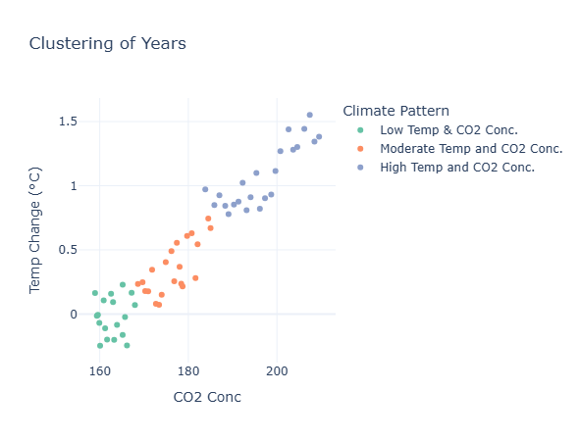
The progression from green to orange and then to blue clusters reflects a clear trend of increasing temperature change corresponding to rising CO₂ levels, effectively illustrating the correlation between greenhouse gas concentrations and global temperature variations.
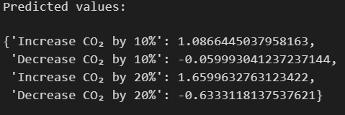
10% increase in CO₂ results in a notable rise in temperature anomalies, which demonstrates the sensitivity of global temperatures to CO₂ levels.
10-20% reduction in CO₂ could lead to significant cooling effects, which will potentially reverse some warming trends.

